Name:__________________________ Period:_____

What did a Tyrannosaurus rex taste like? Online Lab Activity

Objectives: Students will be able to identify and describe methods used to reveal phylogeny. Students will be able to construct a cladogram using inherited characters as evidence.

Go to: http://www.ucmp.berkeley.edu/education/explorations/tours/Trex/navigation.html

This activity consists of exploring 5 folders.
Day 1: Complete Folders 1, 2 and 3.
Day 2: Complete Folders 4 and 5.
For each folder, answer the following questions.
Folder #1: Life on Earth is very diverse, yet all living things are related. Branching diagrams show how living things are related to each other.
- What are the names of the three major groups of all living organisms?
_________________________________________________________________________

- Eukaryota includes what kinds of organisms?
_________________________________________________________________________
_________________________________________________________________________

- Bacteria includes what kinds of organisms?
_________________________________________________________________________
_________________________________________________________________________

- Archaea includes what kinds of organisms?
_________________________________________________________________________
_________________________________________________________________________

- What is the diagram called that shows the family tree of “James and Frances”?
_________________________________________________________________________

- What is the definition of “common ancestor”?
_________________________________________________________________________

- What is the pedigree (genealogy) diagram called when you turn it upside down so that the oldest ancestors are at the bottom?
_________________________________________________________________________

- Why are family relationships not always obvious (regarding “resemblances”)?
_________________________________________________________________________
_________________________________________________________________________

- What are the two big ideas you learned in Folder #1?
a._________________________________________________________________________
_________________________________________________________________________
b._________________________________________________________________________
_________________________________________________________________________

Folder #2 Lineages can be traced back in time to find a point of common ancestry.
Copy the branching tree diagram that shows how a shark, tuna, frog, human, hare, caiman, and parrot are related. Also label the diagram and show the following:
- The tuna’s distinct history.
- The common ancestor for a tuna and a parrot.
- The shared history for a tuna and a parrot.

Folder #3: Cladograms illustrate evolutionary relationships based upon shared inherited features.

- What can cladograms be used for?
_________________________________________________________________________
_________________________________________________________________________

- How are inherited features (a.k.a “traits” or “characters”) represented on cladograms?
_________________________________________________________________________
_________________________________________________________________________

- We will be dissecting frogs later this year. According to the cladorgram, what 3 features do we, humans, share with frogs?
_________________________________________________________________________
_________________________________________________________________________

- How are shared features used in cladograms?
_________________________________________________________________________
_________________________________________________________________________

Name:__________________________ Period:_____

What did a Tyrannosaurus rex taste like? Online Lab Activity

Objectives: Students will be able to identify and describe methods used to reveal phylogeny. Students will be able to construct a cladogram using inherited characters as evidence.

Go to: http://www.ucmp.berkeley.edu/education/explorations/tours/Trex/navigation.html

This activity consists of exploring 5 folders.
Day 1: Complete Folders 1, 2 and 3.
Day 2: Complete Folders 4 and 5.
For each folder, answer the following questions.

Folder #4: Evolutionary relationships can be used to answer many kinds of questions about the history of life.
Features Tables: As your explore folder 4, fill in this table with a +, 0 or ?.
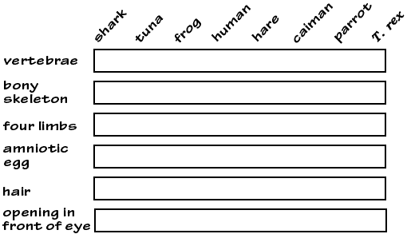 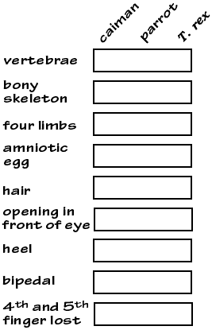

- What animal on the provided cladogram do we think T. rex was most closely related to?
_________________________________________________________________________

- What features does T. rex and this animal have in common that makes us think they are closely related?
_________________________________________________________________________

- So, what did T. rex probably taste like? __________________

Folder #5: We can use cladograms to make inferences about past life, including T. rex.

Purpose:
Use the cladogram and data on inherited features to make hypotheses about what T. rex was like.

Materials needed:
- Cladogram and Additional Data
- Your completed Features Table
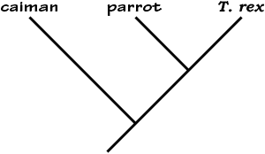

Cladogram
To the right is a simple cladogram indicating the
proposed relationship among the caiman,
parrot, and T. rex.

Additional data
The features table below indicates the presence or absence of eleven additional features for the caiman and the parrot. Notice that the information about the T. rex has not been filled in. Fill in that column with +, 0 or ? based upon what you have learned.
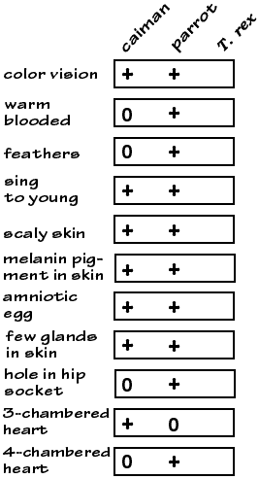
Questions:
- What kind of egg did T. rex likely have?
- Was T. rex warm-blooded or cold-blooded?
- Could T. rex have had feathers?
- What kind of vision did T. rex likely have?
- How many chambers were there in the heart of T. rex?
- What kind of vocalizations did T. rex likely use with its offspring?
- Did T. rex likely have oily skin or dry skin?
- Did T. rex likely have scaly skin or soft skin?

